HTML Day 2HW Assignment

**1 Design a web page having first name, last name, gender[use radio button], qualification 10th,12th,Graduation[use check box], mail address field, mobile number and a submit button.**

**2 Rotate a text from left to right and top to bottom.**

**3 Design a web page having first name, last name, gender[use radio button], qualification 10th,12th,Graduation[use check box], mail address field, mobile number and a submit button. Add a search link to open Google's website.**

**4 Add static profile image in Q3.**

**5 Provide download dialog box on click static profile image added in question no 3**

**6 Add select your city option[use select tag] in Q3.**

**7 On submitting, open a new page and display thank you message Add in Q3.**

8 Show an educational video using youtube on a webpage

9 **Continue Q6 on new page show navigation it looks like Home | About Us | Courses | Enquiry**

10 How to make html text formatting Display in this format This issubscript *and* superscript

11 Design web page using image files image1.jpg,image2.jpg,image3.jpg according to the following specifications

* Use a border for image1
* Resize the height and width of image2 & image3 to 100pixels each
* Align the text with respect to images so as to obtain the output displayed in the below image for your reference

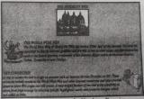

12 Design Form same as below image

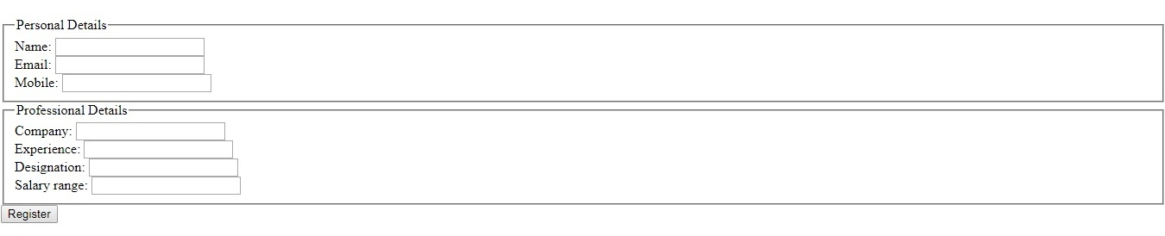

13 Design web page as mentioned below image. Use iframe tag

